Chinese
Arts

Calligraphy
The Seal Form (篆书)
- with soft lines of strokes and upright rectangular shape
- close to pictography (象形文字)
- has a balanced and symmetrical (对称的) pattern.
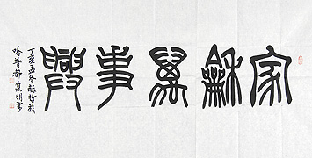
The Official Form (隶书)
- turning point in the evolution of Chinese scripts
- foundation of the later script forms
- turned the remaining curved and round strokes of the seal form into linear (直线的) and flat square (扁方形) shapes.
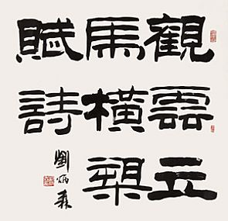
The Cursive Form (草书)
- smooth and lively with strokes flowing and characters linking together
- often joined, with the last stroke of one merging into the initial stroke of the next.
- executed freely and rapidly
- appear exaggerated (夸张的)
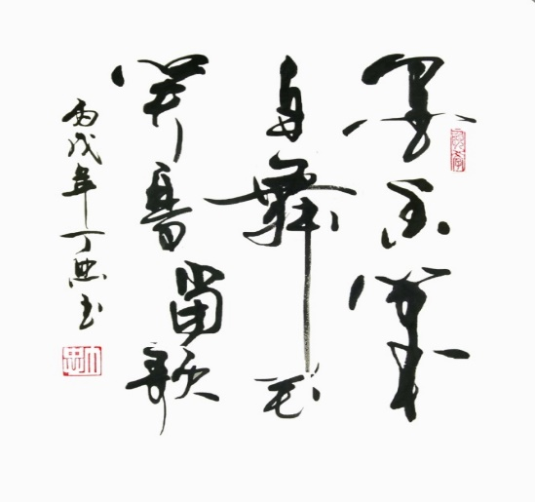
The Running Form (行书)
- somewhere between the regular and the cursive forms
- allows simpler and faster writing
- can be classified into the running regular form (行楷) and the running cursive form (行草)
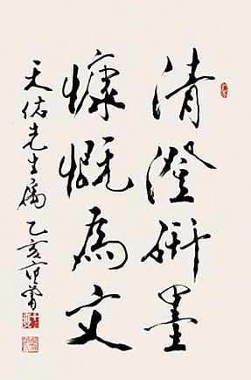
Four Great Regular Script Masters
Ouyang Xun
Yan Zhenqing
Liu Gongquan
Zhao Mengfu

Painting
Outline
- said to have the same origin as calligraphy
- traditional Chinese painting --- ink-wash painting can be
traced back to the Tang dynasty
- achieve an artistic unison by combining fine art, poetry,
calligraphy, and seal engraving
Hui ink stick
- produced in Huizhou, Anhui province
- made from the ash of burnt green pine and mixed with glue
- the writing will not easily fade

Xuan paper
- originally produced in Jing county under the jurisdiction of Xuanzhou
- snow-white, durable, absorbent and moth-proof
- principle type of paper for traditional Chinese calligraphy and painting

Duan ink slab
- first introduced in Duanzhou, Guangdong
- fine, solid and glossy
- ink prepared in it doesn’t dry
- in various shapes and designs, also served as fine desk ornaments

Traditional Operas
- Beijing Opera
- Other Major Traditional Chinese Operas (Kungqu Opera, Henan Opera, Sichuan Opera, Shaoxing Opera, Huangmei Opera)

Beijing Opera
- originally a form of local theatre, then a national opera of China
- the four basic skills include singing, recitation, acting and acrobatic fighting
- the four major roles include sheng, dan, jing and chou
- has distinguished facial make-up and costume

Sheng, Dan, Jing and Chou
- the four roles include sheng (male), dan (female), jing (male with a painted face) and chou(clown)
- classified according to sex, age, disposition, profession, and social status

Sheng
- generally positive
- can be divided into laosheng (老生: elderly men), wusheng (武生: military men), xiaosheng (小生: young men), and wawasheng (娃娃生: children)

Dan
- refers to various female roles
- includes laodan (老旦), qingyi (青衣), huadan(花旦), wudan(武旦) and caidan (彩旦)

Jing
- male with painted face
- also known as hualian (花脸)
- romantic and exaggerated role
- classified into zhengjing (正净: primary face-painted role), fujing (
副净: secondary face-painted role), and wujing(武净: military face-painted role)

Chou
- sharp-witted, clever, humorous, honest and kind men
- classified into wenchou(文丑: comic civilian role) and wuchou (武丑: acrobatic-fighting comic role)

Facial Make-up and Costume in Beijing Opera
- different types of make-up are consistent with the
characters they perform
- to understand the color and the pattern and lines
drawn on the face are the two ways to distinguish a
character’s role or personality
- different colors and forms of costume can be found
for different characters

Other Major Traditional Chinese Operas (Kungqu Opera, Henan Opera, Sichuan Opera, Shaoxing Opera, Huangmei Opera)

Kunqu Opera
- one of the oldest operatic forms
- considered the mother of many other types of traditional opera
- put on the list of the Oral and Intangible Cultural Heritage by UNESCO

Henan Opera
- one of the most influential Chinese local operas
- also called Henan Bangzi
- popular in the areas of the Yellow River and Huai River
- noted for demanding melodies, strong rhythms and intensive use of spoken language

Sichuan Opera
- with a strong literary quality
- full of wit, humour and lively dialogue with a pronounced local flavour
- with unique system of stylised movement
- famous for “face changes (变脸)”

Shaoxing Opera
- originated in Shengxian county, Zhejiang province
- evokes sentimental emotions
- with soft and gentle music and graceful acting style

Huangmei Opera
- local opera in Anhui province
- easy to understand as it uses simple words and literary traditions
- mixed with northern and southern Anhui dialects

Folk Performing Arts
Acrobatics
- has been in existence for over 2000 years
- Chinese acrobatics enjoy fame around the world and play a dominant role

Quyi
Crosstalk
- characterized by talking, imitation, fun-making, and singing
- with satire as its main purpose
- classified into three types: comic monologue, comic
dialogue, and group crosstalk
Clapper talk
- the comic rhymes or monologues are delivered with
the accompany of bamboo clappers
Pingshu
- the comic rhymes or monologues are delivered with
the accompany of bamboo clappers
Short play
- about 15 minutes in length
- short, light comedies in the Huaju (spoken drama) style
- popular on China’s Spring Festival Gala Show for
decades

Puppet Play
- with a long history of over 2000 years
- combines elements of singing, dancing, painting, and sculpture
- the puppets were moved by the actors using sticks and strings
- usually accompanied by tunes from local operas
Shadow Play
- the figures are reflected on a screen by lantern light
- the shadow puppets are valuable folk handicrafts
- collected by many museums and enthusiasts

Traditional Musical Instruments
Drum
- a hollow cylinder or
hemisphere
- played by beating the
membrane with hands
or sticks
Gong
- made of copper
- in the shape of a disk
- beaten with a wooden hammer
ceremonial horn
- a woodwind instrument
- mouthpiece made of brass, body made of wood
- produce resonant sounds
- can be played in bands or as a
solo instrument
bamboo flute
- made of bamboo
- with a row of holes, bamboo membrane and a sound- adjusting hole
- played horizontally
- the vertical bamboo flue is called xiao

